Practical - 2

Aim: -
Simulate communication between two office branches located in different cities. Build a network that enables devices from both branches to exchange information reliably, and test whether data can travel seamlessly between the locations.

Theory : -
When two office branches are located in different cities, they require a Wide Area Network (WAN) to communicate. WANs interconnect local LANs of each branch using technologies such as leased lines, MPLS, VPN over the internet, or dedicated fiber links. Routers at each branch manage traffic routing, while protocols like IPSec VPN, BGP, or static routing ensure secure and reliable connectivity.
Testing seamless data transfer involves validating connectivity with ping, traceroute, file transfer tests, and VPN tunnel status. This ensures that data packets can travel across the WAN reliably, maintaining communication between branches.

Output: -
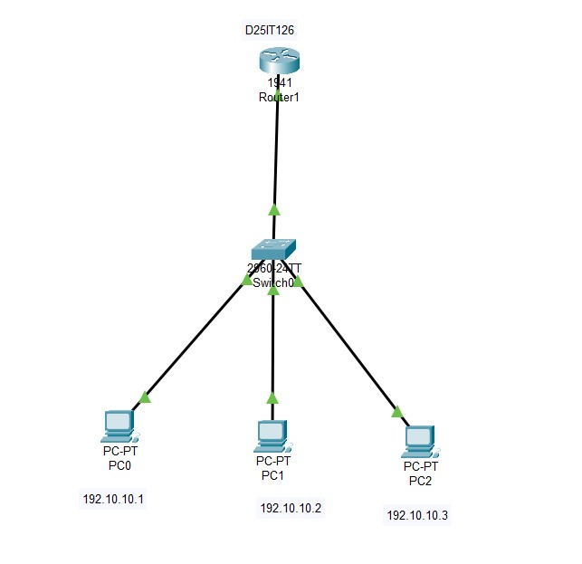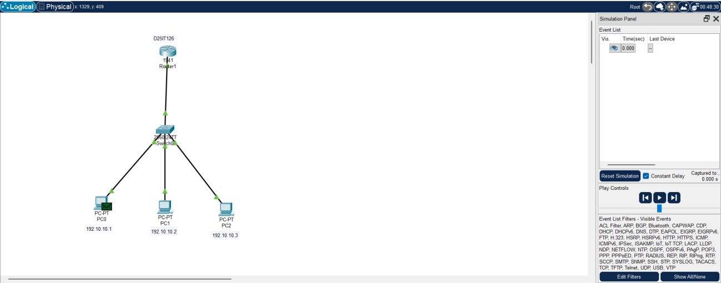

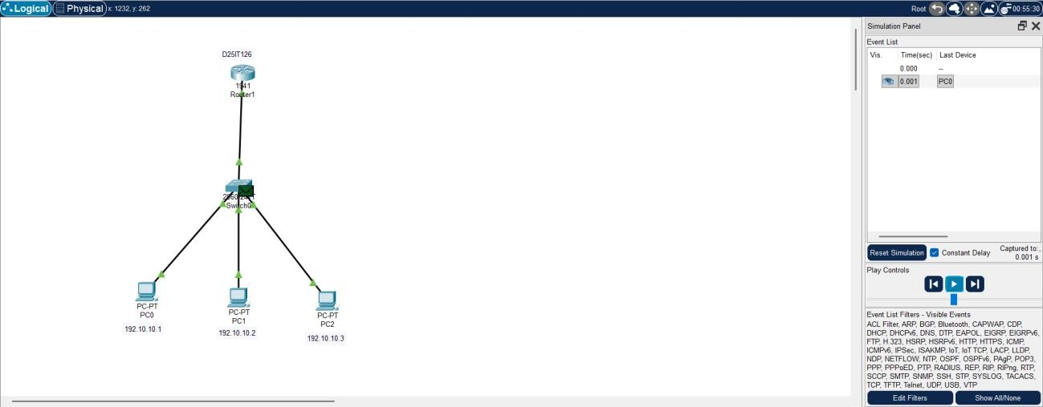
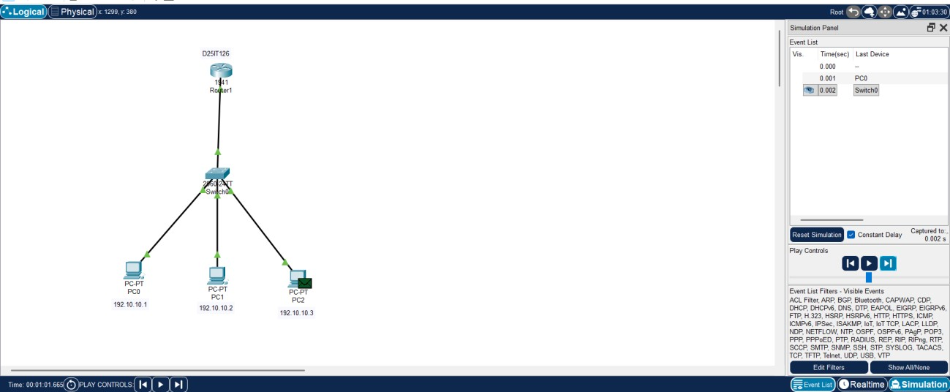

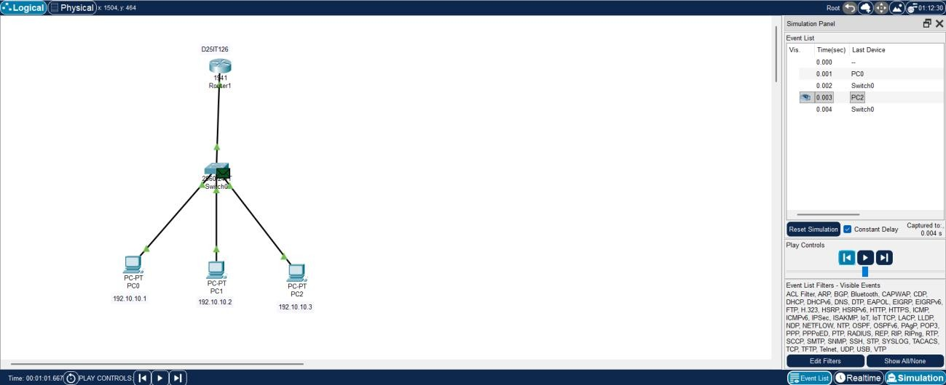

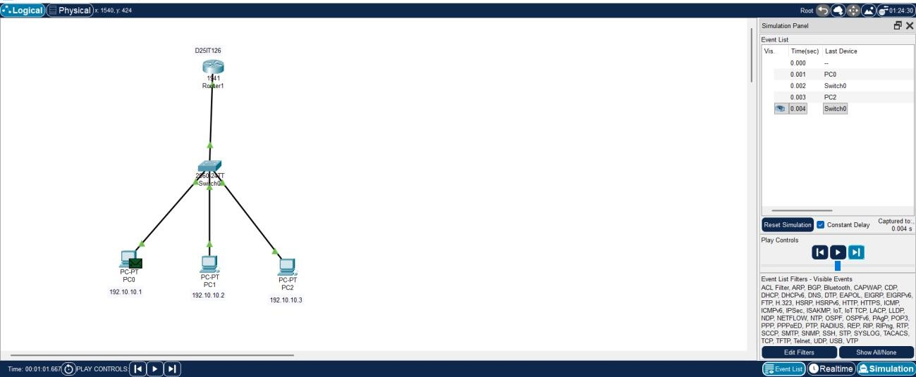

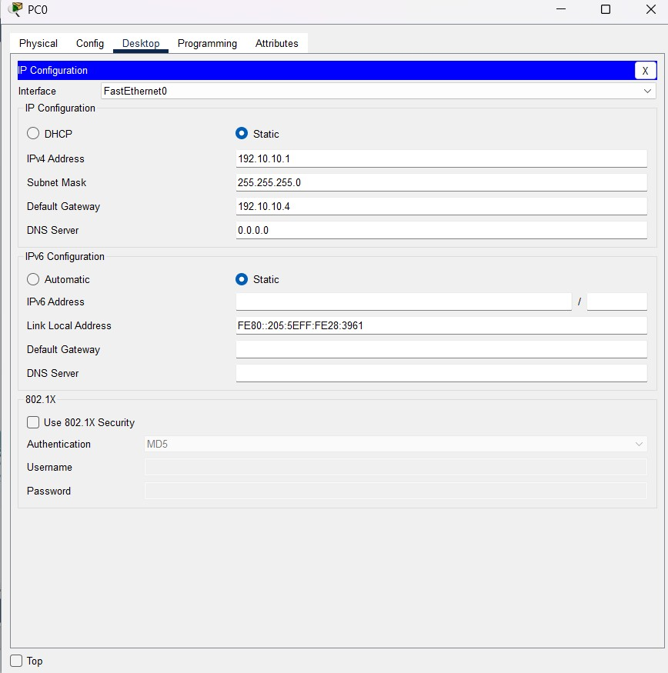

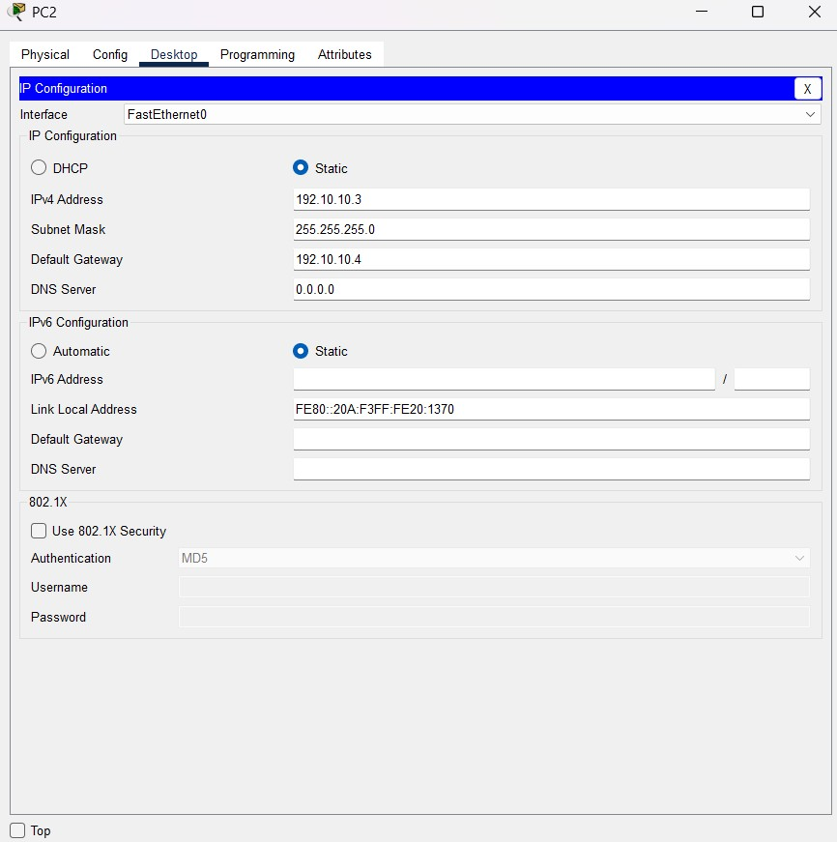
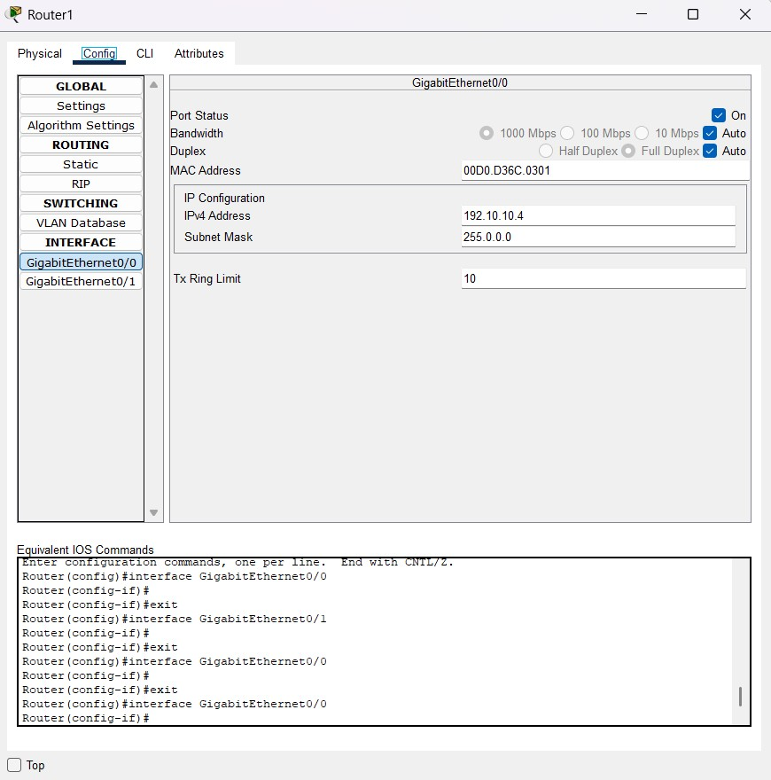
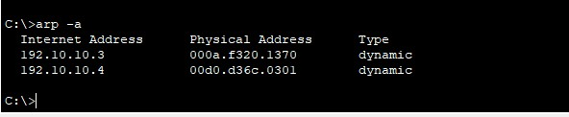
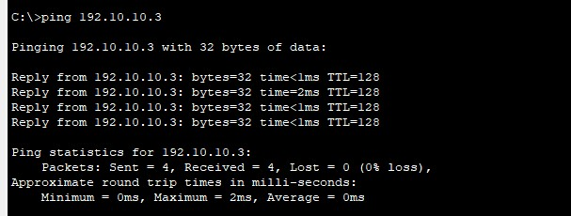

Conclusion: -
By building a WAN (e.g., via VPN or leased lines), both branches in different cities can securely exchange data and communicate seamlessly. Proper routing, addressing, and security configurations ensure that employees at both locations can collaborate as if they were on the same network.

Q & A: -
Q1. What type of network is required to connect offices in different cities?
A: A Wide Area Network (WAN).

Q2. Which device connects local LANs of two different offices over a
WAN?
A: A router.
Q3. What is a VPN and why is it used between two branches? A: A VPN (Virtual Private Network) securely connects remote branches over the internet by encrypting data.
Q4. How can you test whether two branch offices are connected properly?
A: By using tools like ping, traceroute, and testing file transfer across the WAN.

